
Campbell Valley Trail
Crew Leader Notes

Overview
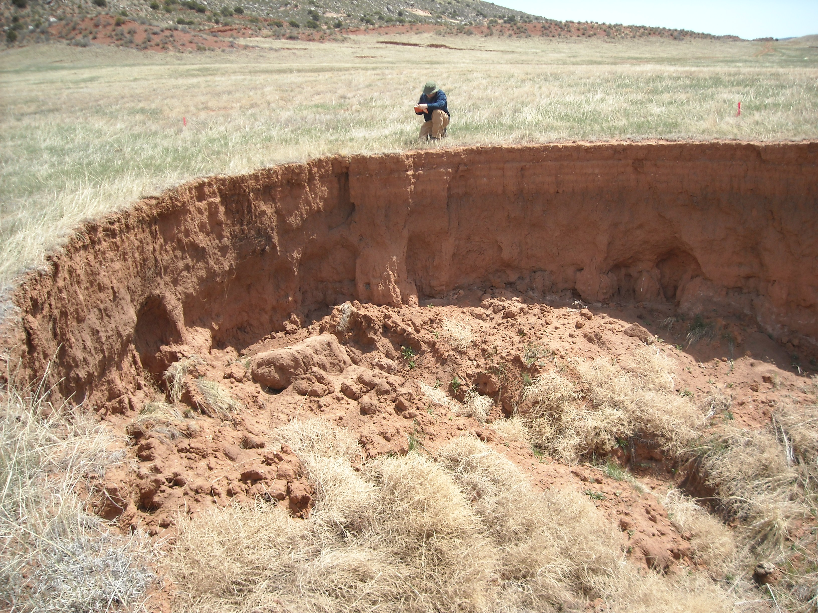
History Campbell Valley lies about 30 miles north of Fort Collins in one of the most important foothills-plains transition zones in the Front Range. This is a fascinating, historic, large private ranch that is subject to a conservation easement by The Nature Conservancy. In the early 1900's, the North Poudre Irrigation Canal breached, flooding Spring Gulch, the primary spring-fed creek in the Campbell Valley. The elevation of the creek was down-cut by as much as 40 feet, causing the elevation of most of the valley tributaries to drop commensurately (tributary rejuvenation). This massive change in the watershed has caused head-cutting and down-cutting of every tributary in the valley, resulting in the estimated loss of over 4,500,000 (that's right, Million) cubic yards of sediment. Gullies range from 5 to 30 feet deep and run up to 1,000 feet long. The riparian shrubland and forest that once existed along the creek has been replaced by a much simpler and less biologically diverse wet meadow.
This project is part of a long-term, valley-wide restoration plan that involves multiple partners and which will support improved grazing management practices with strategically placed, hardened water gaps and fencing; restores the diverse riparian shrubland and forest plant communities, and stabilize and heal the existing gullies. This is a multi-phase and multi-year restoration program.

We will be working in the former spillway from Evan’s Reservoir. It breached in the mid-80s and began headcutting toward the reservoir. In 2012 the dam was removed, and the reservoir converted to a wetland. The flow was diverted from the rapidly eroding spillway to its natural channel. Now we are working to help this landscape stabilize and revegetate.

Details

Location Evan’s Spillway and Leaky Creek in the Campbell Valley
Meet at the Livermore Community Hall and carpool to site

Schedule Sunday, March 31, 2019 9:00 – 4:00. See training schedule for greater detail.

Personnel
The project will have approximately 35 volunteers for 1 day. Leadership personnel are as follows:

First Name | Last Name | Role
Dirtbag | Pulaski | Crew Leader Instructor
Brandoff | Blue | Crew Leader Instructor
Connie | Johnson | Crew Leader Instructor
Luke | Tembrock | Crew Leader Instructor
Mick | Syzek | Project Leader
Bob | Johnson | Technical Advisor
Robert | Van Dopp | Tool Manager
Nate | Boschmann | WRV Staff Liaison
Zach | Thode | Agency Staff

Site Map
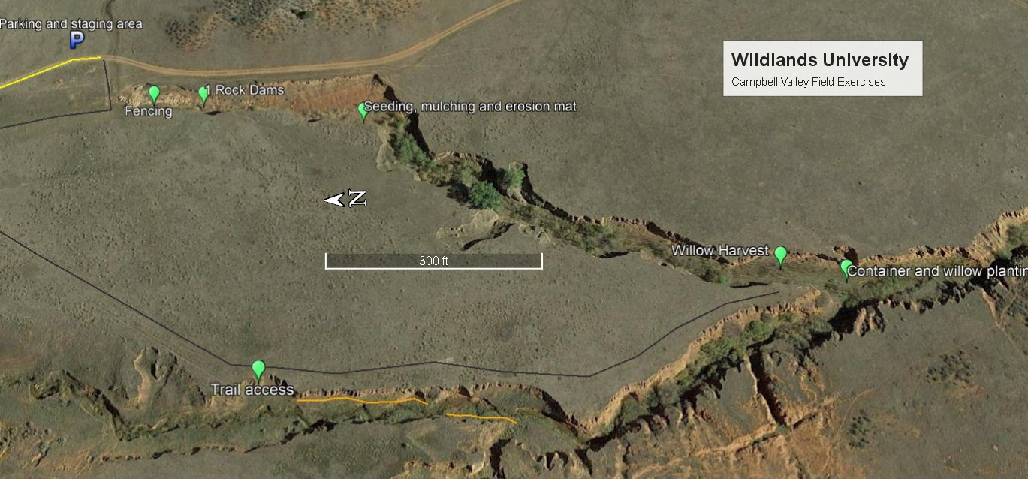

Safety

The terrain is flat, heavily vegetated, and usually close to water or marsh. The safety issues relevant to the site are given below.
- Barbed wire: This is cattle country. Barbed wire can be anywhere. Have your crew members be alert at all times.
- Uneven terrain, tires, and “cow” holes: Walk mindfully. It’s pretty easy to twist an ankle out there, and stepping in a hole could cause a broken bone or ligament/tendon damage in the ankle or knee.
- Working in mud and water along stream banks: It would be easy to twist an ankle or fall on a tool while working on the stream banks or in mud.
- Rattlesnakes: Pay particular attention in rocky areas and livestock trails (open areas) where the snakes may be sunning themselves.
- Heat exhaustion and sunburn: The site will be exposed to direct sun with little shade available. Encourage your volunteers to drink plenty of fluids and be aware of sunburn and overheating. Make sure crew members pace themselves. Crew leaders should constantly monitor their crews for signs of heat exhaustion (light-headedness or dizzy) and remind volunteers to drink fluids, take frequent breaks, and use sunscreen.
- Lightning: There is a chance for thunderstorms any time in the plains. We will be relatively close to our vehicles. So, if thunderstorms develop, head to the safety of the vehicles. Remember to keep 30 feet of space between volunteers as you head to the vehicles.
- Tool Use: Of course, improper use of tools poses a threat to the safety of crew members. Crew leaders need to explain proper use and transportation of tools at the beginning of the work day.

Communication

Each Crew Leader will be issued a talk-about radio. We will be working fairly close together, so radio communication should be feasible. Cell phone reception is spotty.

Incidents and Injuries See WRV Emergency Response Plan

The following steps will be taken by WRV Team Members in the event of an emergency.
- The project medic, or the person on the crew who has the highest level of appropriate emergency medical experience, will determine if emergency medical services are necessary. - If off-site emergency medical services are necessary, the project medic will contact Nate Boschmann (WRV Staff Liaison) who will contact emergency services (911) on his cell phone. For all serious injuries, please ensure that an Incident Report Form is completed.

Who communicates with emergency personal during an emergency?
The Project Medic is responsible for communicating with emergency personnel or delegating that responsibility as they see fit.

What is the plan for supervising the remaining volunteers while treatment/assistance is being rendered? The Crew Leader will manage the crew as necessary to reduce chaos during the emergency event and reduce the likelihood of another volunteer getting injured. As long as there isn’t an ongoing threat to other volunteers, volunteers should be encouraged to continue their work at a suitable distance away from the emergency scene.

WORK DESCRIPTION

We’ll be constructing an access trail to some long term restoration sites on Leaky Creek. Construction will be 18” full bench trail. In the absence of native rock we will be using native tire for the necessary structures. There are 4 work sections as follows:

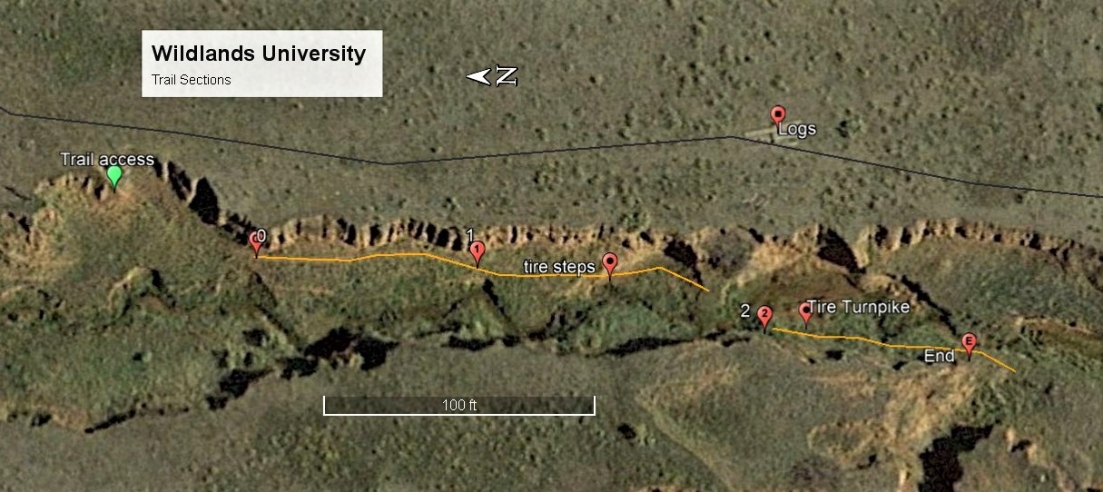

Section Notes

TOOLS LIST PER CREW (Instructors plus 6 volunteers)

6 | Trail Crew |  |  | 2 | total
 | 1 | Mini pick |  |  | 2 | Mini pick
 | 1 | Brewery blanket |  |  | 2 | Brewery blanket
 | 1 | Single Jack |  |  | 2 | Single Jack
 | 1 | Folding Saw |  |  | 2 | Folding Saw
 | 1 | Rock austin |  |  | 2 | Rock austin
 | 1 | Rock bar |  |  | 2 | Rock bar
 | 2 | Pick mattock |  |  | 4 | Pick mattock
 | 2 | Spade shovel |  |  | 4 | Spade shovel
 | 2 | McLeod |  |  | 4 | McLeod
 | 3 | Canvas bag |  |  | 6 | Canvas bag
 | 6 | Safety glasses |  |  | 12 | Safety glasses
 | 6 | Hardhats |  |  | 12 | Hardhats
Trail Construction Steps

Utilizing best practices as promoted by OSI, the Outdoor Stewardship Institute, IMBA, the International Mountain Bicycling Association, we will follow the Six Step Process for Basic Trail Construction. Please bring your OSI Quick Reference Cards (Caribineer Cards) to share the visual info with crew members.
Step 1: Clear Corridor: If all or part of shrubs’ root mass is in the tread, consider leaving about two feet of branch material to help pull on for root removal when digging out. Otherwise, if shrubs are not in tread, trim back judiciously all the way to ground – please do not leave sharp points at trail’s edge
Step 2: Establish Starting Point of Construction: Pin flags will mark the Critical Edge of the tread. Yes, we do have some wiggle room, but if you, the Crew Leader, think we need to relocate tread more than six inches off line, please first consult the Technical Advisor.
Step 3: Establish Initial Tread Surface: As a suggestion, the most efficient way to begin digging without removing way too much mineral soil is to stand with both feet on the tread and peel layers off the tread from the Critical Edge in towards the hinge point of the tread. Once you find mineral soil, you should not have to dig much deeper at that outside edge. Refer to paragraph above on Impact Management. All material removed from the tread should remain on the tread for dispersal or stockpiling, not scraped over the edge. (See notes below and Section Notes for details.) Like peeling an onion, remove layers in several passes to level the tread down to average 3-5% outslope. Try to leave the pin flags in for reference until a rough tread is well established. Big rocks in the tread – keep or remove? Removing a big rock from the tread will leave a big hole to fill. Does rock have to come out? Or can we reduce it with a large sledge, or chisel off the top to tread height with a small hand sledge and chisel. To fill a large hole in the tread, please fill in 3-4in. layers of crushed rock and mineral soil. The objective when filling a large hole is to minimize air voids that will trap water by compacting in layers to form a matrix of material.
Step 4: Establish Backslope: All material removed to shape the backslope should again end up on the tread for dispersal or stockpiling. (See below.)
Step 5: Establish Outslope: If you have been keeping material off of the Critical Edge, the tread outslope and Critical Edge should be able to be finished in one pass!
Step 6: Reclamation and Finish Work: This is the step where we focus on finishing the trail section to have it appear to have been there for two years or more. Clean up the site (leave the rocks parked), and spread some duff and organic material on disturbed areas to the side of the trail tread to mimic the surrounding landscape. Trailbuilding is part science and part art. This is part of the art, the aesthetic of the landscape.
About 15 to 30 minutes before you as Crew Leader believe you will be finished with your section, please contact the Technical Advisor via runner to review section with your crew prior to moving up to your next work area.
Dispersal of Removed Material (Unless otherwise specified in your Section Notes)
Most organic material can be widely broadcast downwind (not necessarily downhill) by shovel unless Section Notes direct otherwise. You may wish to stockpile a small amount of duff for aesthetic edge dressing of disturbed surfaces off the tread during the reclamation phase to mimic the surrounding landscape. (Do not stockpile poison ivy!)
Unless directed otherwise by the TA, stockpile all surplus mineral soil for filling holes created by removing large rocks, and for rock wall construction in nearby sections.
Rocks in tread – stockpile all rock larger than fist-size safely and securely on the uphill side of the trail, as there may be future need for filling holes in the tread or building rock walls. In sections adjacent to climbing turns, all surplus rock may be stockpiled for use in the turn structure or as backfill. Please do not allow rocks to be thrown, tossed, or rolled downhill – rock “trundling” can present serious safety hazards when crews are working above each other near climbing turns.
Leave No Trace Trail Construction

As part of a serious effort to minimize the potentially considerable impact of volunteers on our semi-arid, fragile landscape, Crew Leaders are asked to frequently monitor and encourage all travel along the centerline flags as much as possible. Nearly all the trail work can be thoughtfully accomplished while standing with both feet on the tread. Encourage all material to be scraped, raked, or dug towards the center of the tread for removal or dispersal. Protect the Critical Edge.
Please discourage crewmembers from standing below and perpendicular to the tread, pulling material off the tread and downhill over the Critical Edge, as this only creates a “trash zone” that will require subsequent cleanup. We are not building a fire line. The goal is to open the trail reroute to the public in and have it look “weathered in” enough for visitors to believe it has always been there.

Common Construction Techniques
Trail terminology

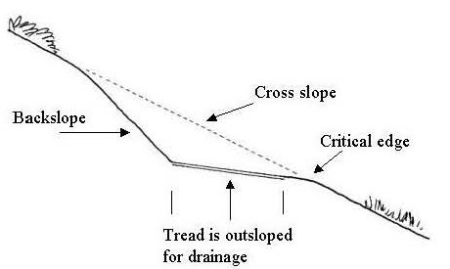

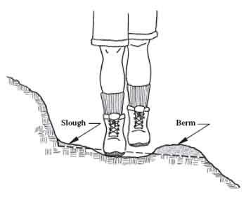
Slough accumulates below an unstable backslope.
Berms form as vegetation captures loose material along the untraveled critical edge. This captures water which compounds the problem as additional tread material is washed away.
Reestablish 3-5% outslope by cutting out berm and slough.
Add periodic drainage structures as needed.
Deberming

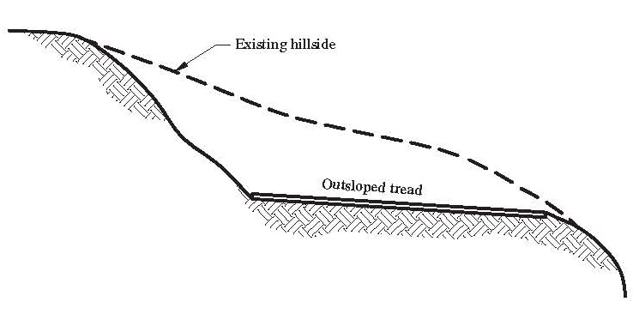
Excessive outslope or trip hazards cause users to widen the tread or create braiding.
Reestablish 3-5% outslope and remove trip hazards to make intended trail more inviting.

Outsloping
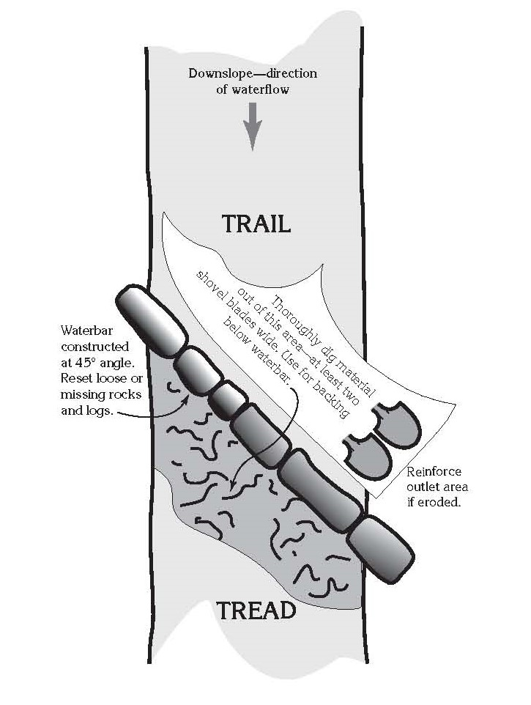
Repair existing drainage structures and add new ones as indicated.
Remove accumulated material from drainage outlet
Use substantial rocks buried at least 1/2 into the tread.
Dig drain so that water exits the trail with no abrupt changes in direction before contacting the rocks.
Drainage Maintenance
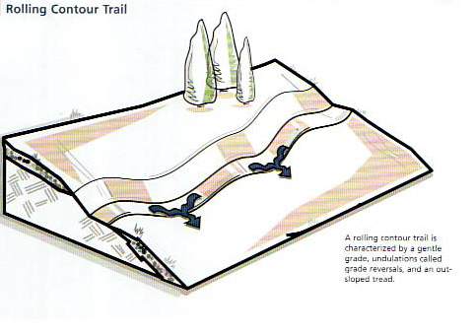
Drainage
Newly constructed trails will incorporate drainage into the design with periodic grade reversals.
You may not even notice you are constructing one because they are sometimes very subtle.
A shortened version often added later is called a drainage dip.
This method is more sustainable and saves on maintenance.
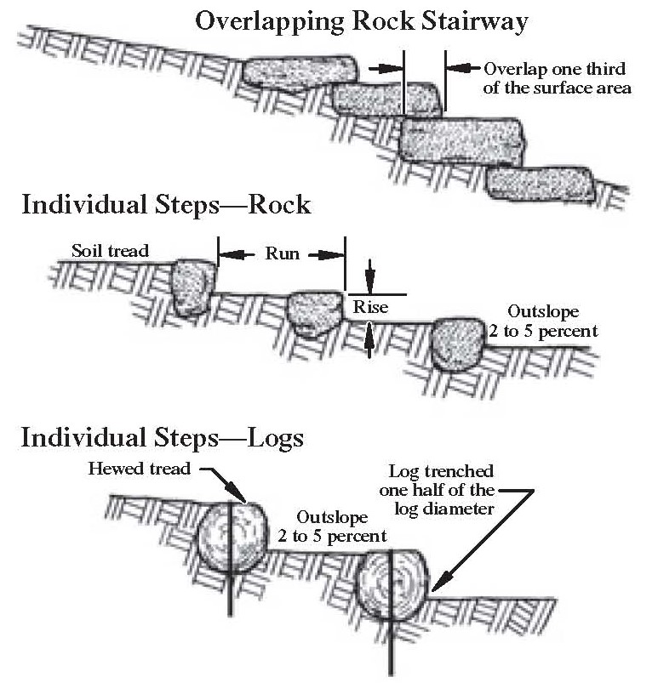
Similar construction to monowall construction except perpendicular to tread.
This will often take more than one rock to span width of tread.
Can be used to build up an incised trail like a check dam.
If drainage is an option drain before steps.
Use gargoyles to avoid users flanking the steps.
Steps

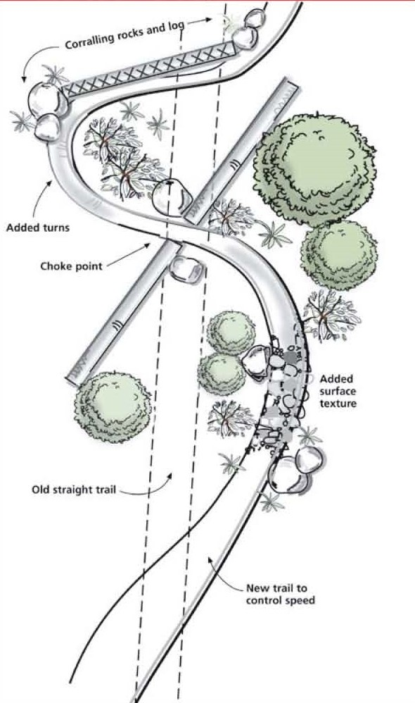
Use large rocks and logs to create periodic pinchpoints to encourage users to stay within the trail.
DO NOT line the trail with rocks or logs. This will exacerbate the already existing drainage issues on the trail.
Use additional slash and duff to create the appearance of an undisturbed surface.
Where trail is excessively wide staggered gargoyles may be needed to block remainder of closed braids.
Gargoyles

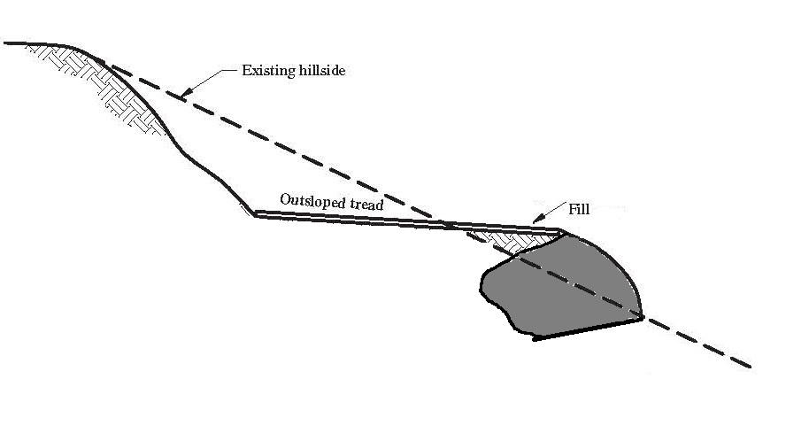
Monowall
Dig bench slanted in toward the trail.
Use rocks large enough to hold their own and create at least two points of contact with neighboring rocks.
Bury upper part of rock under tread whenever possible to facilitate drainage.
Never rest rock on disturbed soil or shim rocks from the outside

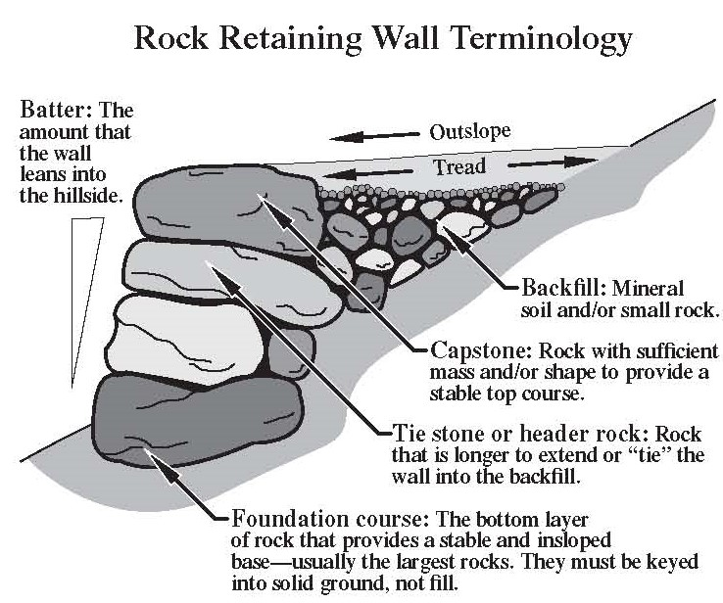
Rock Walls
Batter or slant the individual stones into the hill.
Achieve as many stable points of contact between rocks so that each rock is stabilized and doesn’t move. Additional wedge rocks may be placed from the back of the wall never the front.
Use periodic Tie stones that extend under the tread to help hold the wall in place.
Crush in smaller rock behind the wall to facilitate drainage and reduce frost heave.
Top with mineral soil.

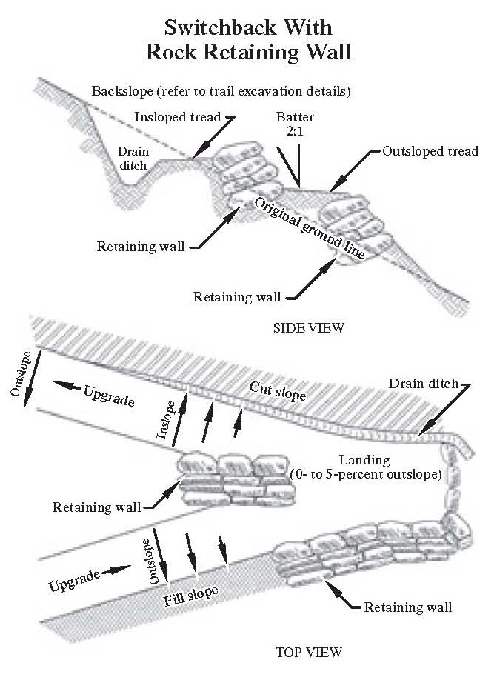
Switchbacks
There are many types of structures that facilitate turns on steep slopes. The most common is a switchback though most multi use trail will employ a more rounded climbing turn.
Switchbacks are often shortcut by hikers. Use rock and log gargoyles to block potential shortcuts.
Reestablish drainage and walls where necessary. For climbing turns employ drainage dips before and after the structure.

